VOL

Overview

Current processing
New functionality.

New requirement
- The User selects the VOL screen of the Trader GUI.
- The system displays the screen where the user has to manually enter the class name for which volume related information is required.
- Systems performs the validations and captures the time of request.
- The system then captures and computes the required information which is then displayed on screen and saved.

Scope
Send report to GUI from the pre-populated ProductClassVolumeStruct. The population of ProductClassVolumeStruct will be implemented as part of Market Data Report Service.

Assumptions:
Validations for the Training Test classes and Industry Test classes are not to be considered.

Implementation

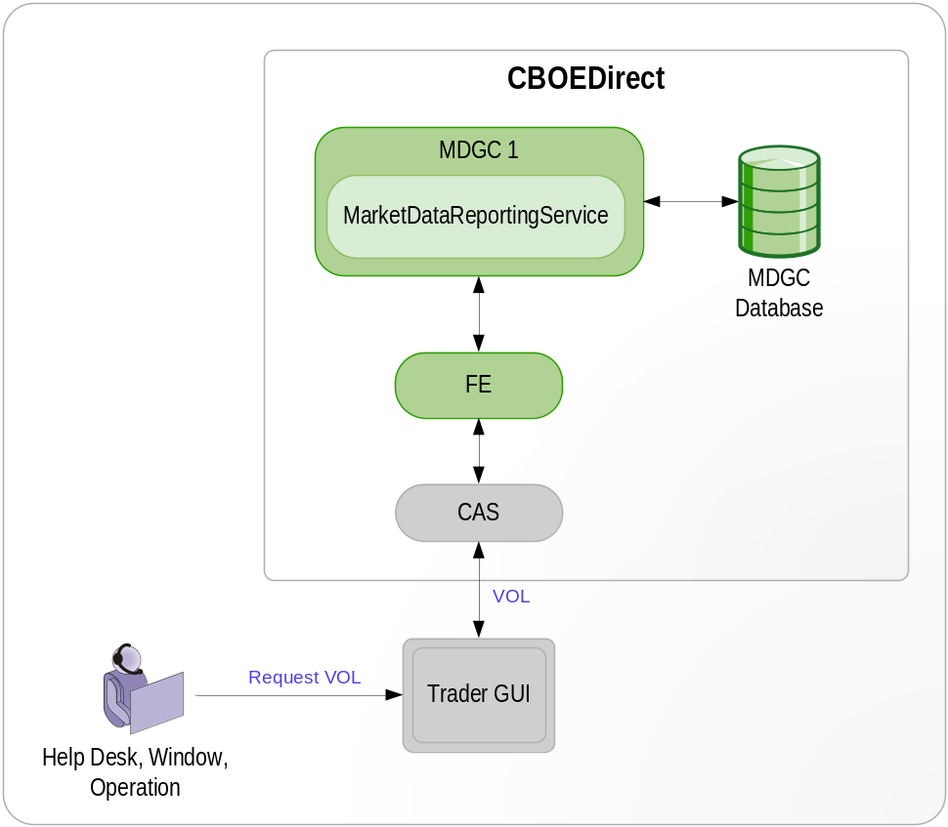

- VOL Report Flow:
- GUI calls the method public ProductClassVolumeStruct getProductClassVolume(String sessionName, int classKey) of MarketDataReportServiceRoutingProxy.java (Front End) for getting the volume related information by giving the sessioName and classKey as input parameters.
- MarketDataReportServiceRoutingProxy then delegates the request to the MarketDataReportService by calling the method public ProductClassVolumeStruct getProductClassVolume(String sessionName, int classKey) of MarketDataReportServiceImpl.java.
- The method getProductClassVolume validates for the classKey, if it is existing or not and if not it throws the NotFoundException with the message that no products for this class found.

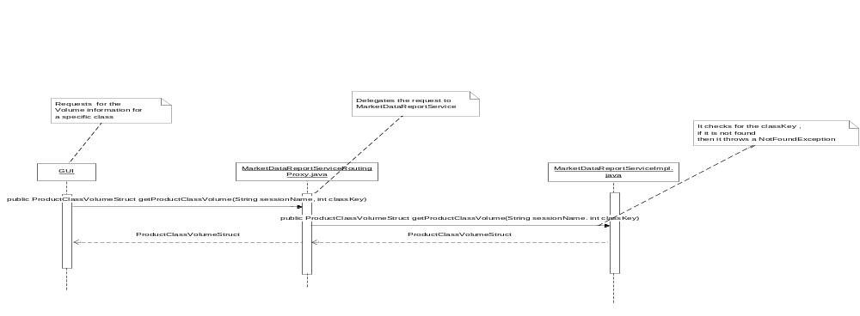
Logic to build ClassVolumeStruct:
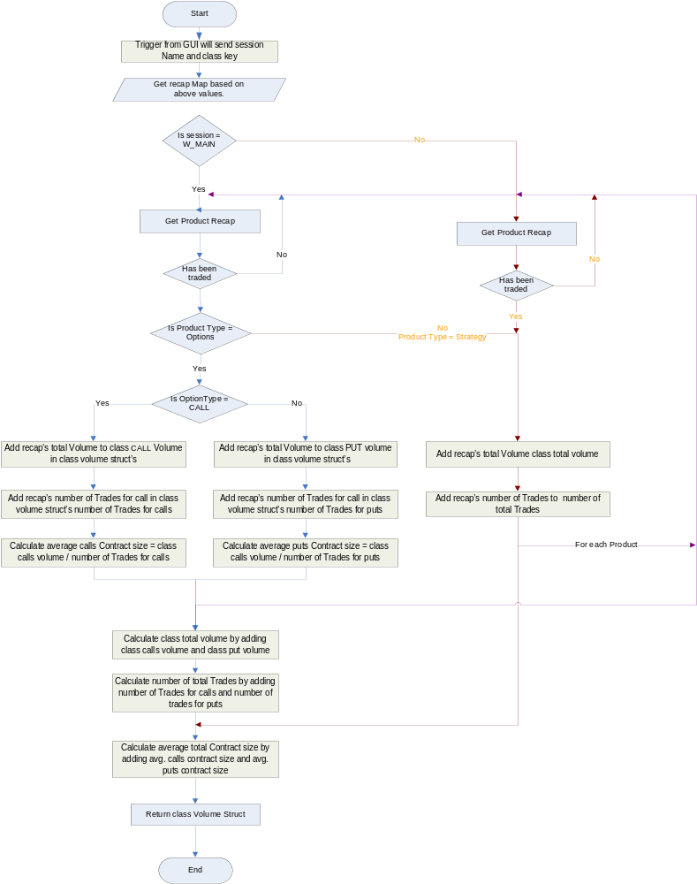

- IDL Changes
- MarketDataReportService.idl
Location : /vobs/dte/server/idl
Add the following method to the interface MarketDataReportService.
  - cmiProduct::ProductClassVolumeStruct getProductClassVolume(in string sessionName, in cmiProduct::ClassKey classKey)
raises(
exceptions::SystemException,
exceptions::NotFoundException,
exceptions::DataValidationException,
exceptions::CommunicationException,
exceptions::AuthorizationException
);

- Add the ClassVolumeStruct
Location: /vobs/dte/cmi/idl/cmiMarketData.idl
- struct ClassVolumeStruct
{
long classCallsVolume;
long classPutsVolume;
long classTotalVolume;
long numberOfTradesForCalls;
long numberOfTradesForPuts;
long numberOfTotalTrades;
long averageCallsContractSize;
long averagePutsContractSize;
long averageTotalContractSize;
};
- struct ProductClassVolumeStruct
{
cmiProduct::ClassKey productClassKey;
cmiMarketData::ClassVolumeStruct classVolume;
};

- Interfaces and Classes:
- FE Changes
  - MarketDataReportServiceRoutingProxyHomeImpl.java
Location: /vobs/dte/server/java/proxies/com/cboe/proxy/businessServices/ MarketDataReportServiceRoutingProxyHomeImpl.java
This class is the home for MarketDataReportServiceRoutingProxy.java.It will have the method for creation of instance of routing Proxy.
      - Extends RoutingProxyHomeBase.java
      - Implements MarketDataReportServiceHome.java
      - Define method public MarketDataReportService create( ). It returns the instance of MarketDataReportService.
      - Define method public MarketDataService find(). This method internally calls getProxyInstance() of RoutingProxyHomeBase and returns the MarketDataReportService instance
      - Define method protected BusinessServiceRoutingProxy createRoutingProxy(). This method creates instance of MarketDataReportServiceRoutingProxy

  - MarketDataReportServiceRoutingProxy.java
Location: /vobs/dte/server/java/proxies/com/cboe/proxy/businessServices/ MarketDataReportServiceRoutingProxy.java
This class is in GC and it extends the GlobalServiceRoutingProxy and implements the MarketDataReportService.
This class is being added to route the VOL request to MarketDataReportService.
    - Add the method public com.cboe.idl.cmiMarketData.ProductClassVolumeStruct getProductClassVolume( String param0, int param1)
throws com.cboe.exceptions.SystemException,
com.cboe.exceptions.NotFoundException,
com.cboe.exceptions.DataValidationException,
com.cboe.exceptions.CommunicationException,
com.cboe.exceptions.AuthorizationException
    - This method will delegate a call to public productClassVolumeStruct getProductClassVolume(String sessionName, int classKey) of MarketDataReportServiceImpl.java

  - MarketDataReportServiceProxy.java
Location: /vobs/dte/server/java/proxies/com/cboe/proxy/businessServices/ MarketDataReportServiceRoutingProxy.java
    - Add a method public com.cboe.idl.cmiMarketData.ProductClassVolumeStruct getProductClassVolume(String param0, int param1)
throws SystemException, NotFoundException,
DataValidationException, CommunicationException,
AuthorizationException
        - This method will delegate the request to MarketDataReportService

- MarketDataReportService Changes:
MarketDataReportServiceImpl.java
Location:vobs/dte/server/java/impls/com/cboe/businessServices/marketDataReportService/ MarketDataReportServiceImpl.java
    - Add a method public ProductClassVolumeStruct getProductClassVolume(String sessionName, int classKey) throws SystemException, NotFoundException, DataValidationException, CommunicationException, AuthorizationException
      - Queries the MarketDataReportProcessorHome and checks if the passed sessionName is configured for the server. If not throws NotFoundException.
      - Checks if the classkey is not zero else throws DataValidationException
      - Passes the recap cache to ClassVolumeStructBuilder and gets ClassVolumeStruct.
This class thows DataValidationException if no products found for the given classkey.
      - The ClassVolumeStructBuilder class takes care of the following validations for sessions.
        - If the session is W_MAIN and product type is options then all the fields mentioned in ClassVolumeStruct are to be calculated.
        - If the session is W_MAIN and product type is strategy then only three field i.e totalVolume, totalNoOfTrades and TotalAverageContractSize will be calculated and rest all the fields will be zero.
        - For all other sessions other than W_MAIN only the three field i.e totalVolume, totalNoOfTrades and TotalAverageContractSize will be calculated and rest all the fields will be zero
      - Creates the instance of ProductClassVolumeStruct and assigns ClassVolumeStruct and classKey to it.
      - Returns the created ProductClassVolumeStruct.

Scripts(2)
- Makefile
Location: /vobs/dte/server/java/interceptors/Makefile
  - Add the MarketDataReportServiceRoutingProxyInterceptor in Makefile for generating the interceptor in the end of following section
EXCEPTION_INTERCEPTORS=\
com.cboe.proxy.businessServices.MarketDataReportServiceRoutingProxyInterceptor-com.cboe.interfaces.businessServices.MarketReportDataService \

Database(.5)

SetContext(.125)

XML/DTD(.5)

- v20Frontend.xml
Location: /vobs/dte/server/properties/xml/ v20Frontend.xml

  - This xml will be modified for MarketDataReportServiceRoutingProxyHome

<BOContainer name="MarketDataReportServiceContainer">
<BOHome name="MarketDataReportServiceRoutingProxyHome">
<BOHomeProperties>
<homeImpl>com.cboe.proxy.businessServices.MarketDataReportServiceRoutingProxyHomeImpl</homeImpl>
<interceptorName>MarketDataReportServiceRoutingProxyInterceptor</interceptorName>
<interceptorImpl>com.cboe.proxy.businessServices.MarketDataReportServiceRoutingProxyInterceptor</interceptorImpl>
<poaName>FrontendPOA</poaName>
<objectId>MarketDataReportServiceRoutingProxyHome&lt;prefix&gt;Frontend</objectId>
</BOHomeProperties>
</BOHome>
</BOContainer>
  - Adding the MarketDataReportServiceRoutingProxyHome in listOfHomes tag of
<FoundationFrameworkProperties>

Homes/Services(4)
  - MarketDataReportService.
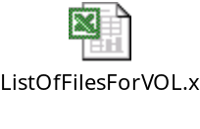

ImplPlan(.5)

PerformanceTestingProcedure(1)

TestingProcedure(1)

OperatorProcedure(.5)

Fallback/Failover

CAS Design

GUI Design

Trade Server State

